Project Design Phase

Technology Stack (Architecture & Stack)

|  |  |
| --- | --- |
| Date | 17 October 2022 |
| Team ID | PNT2022TMID28778 |
| Project Name | Project -- Real-Time river Water Quality Monitoring and Control System |
| Maximum Marks | 4 Marks |

TECHNICAL ARCHITECTURE:

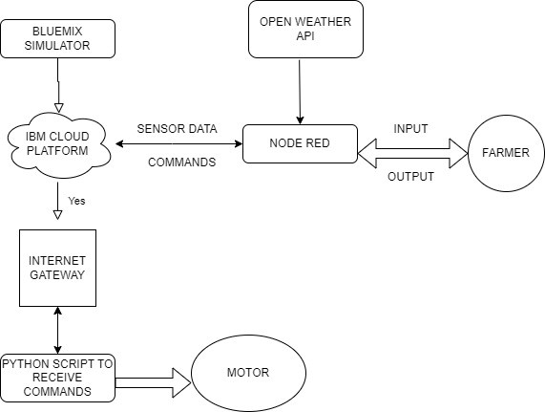

**Table-1 : Components & Technologies**

**Table-1 : Components & Technologies**

|  |  |  |  |
| --- | --- | --- | --- |
| S.No | Component | Description | Technology |
| 1. | User Interface | How user interacts with application | HTML, CSS, Bootstrapping |
| 2. | Application Logic-1 | Logic for a process in the application | JAVA/PYTHON |
| 3. | Application  Logic-2 | Logic for a process in the application | IBM WATSON STT services |
| 4. | Application Logic-3 | Logic for a process in the application | BM WATSON Assistant |
| 5. | Database | Data Type, Configurations etc | MySQL, |
| 6. | Cloud  Database | Database Service on Cloud | IBM cloud |
| 7. | File Storage | File storage requirements | IBM Block Storage or Other Storage  Service or Local Filesystem |
| 8. | External API-1 | Purpose of External API used in the application | IBM Weather API, etc |
| 9. | External API-2 | Purpose of External API used in the application | Aadhar API, etc |
| 10. | Infrastructure | Application Deployment on Local | Local, Cloud Foundry, Kubernetes, etc. |
|  | (Server / | System / Cloud |  |
|  | Cloud) | Local Server Configuration:  Cloud Server Configuration |  |

**Table-2 :** Application Characteristics

|  |  |  |  |
| --- | --- | --- | --- |
| **S.No** | **Characteristics** | **Description** | **Technology** |
| 1. | PH level monitoring | The PH level of river water can be monitored via placing sensors in rivers | PH-sensor |
| 2. | Temperature monitoring | The temperature of river water can be monitored | Temperature sensor |
| 3. | Pollution monitoring | The clarity and purity of river water can be monitored | Conductive sensor |
| 4. | Soil level monitoring | The amount of soil mixed in river water can be measured | Turbidity sensor |